**YTÜ Mechanical Engineering Department**

**Machine Theory, System Dynamics and Control Division – MAK 4981**

**Dynamics of Machinery Lab Notes**

**Location:** A Blok – Machine Theory Laboratory

**Name:** The Dynamics of Machinery

**Subject:** Resonance Analysis

**Device and Material:**

- Vibration Test Beam Setup

- Ruler

- Sample mass

**Recap:**

**Vibration** is basically Oscilation around a equilibrium point.

**Degree of freedom** (DOF) of a mechanical system is the number of independent parameters that define its configuration.

**Amplitude** isMaximum displacement point with respect to the initial position.

**Period** is the duration of time of one [cycle](https://en.wikipedia.org/wiki/Turn_(geometry)" \o "Turn (geometry)) in a repeating event

**Frequency:** Cycle time per second.

**Harmonic Motion**: A type of periodic motion or oscillation motion where the restoring force is directly proportional to the displacement and acts in the direction opposite to that of displacement.



Figure 1 Harmonic Motion

**Resoanance**

In this lab, we will investigate the resonance phenomenna. **Resonance** is a phenomenon in which a vibrating system or external force drives another system to [oscillate](https://en.wikipedia.org/wiki/Oscillation" \o "Oscillation) with greater [amplitude](https://en.wikipedia.org/wiki/Amplitude" \o "Amplitude) at a specific preferential [frequency](https://en.wikipedia.org/wiki/Frequency" \o "Frequency) [1]. It occurs when the frequency of the disturbance force is overlap with the natural frequency of the system.

If designer can not take into account the resonance, the results would be destuctive. In 1940, Tahoma Bridge was collapsed, because the external force frequency ( in this case wind) matched the natural frequency of the bridge.

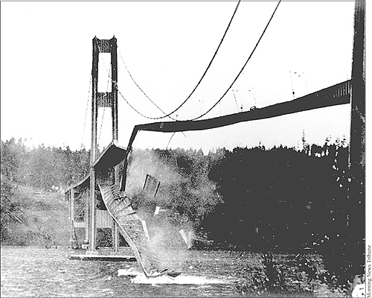

Figure Tahoma Bridge Collapse [2]

**Mathematical Model of The System**

In this part, the mathematical model of the test setup is derived. There are two different methods for the derivation of the mathematical model. In this report, lagrangian approach is applied.

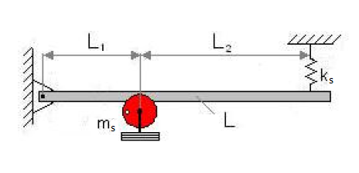

Figure 2. Sketch of the Experimental Test Setup

The system has only single degree of freedom. Thus, we will obtain only one equation at the end.

Firstly, general expreesion of the Lagrange Equation as follows,



In this equation,

Ek : The sum of Kinetic Energy of the System

Ep : The sum of Potential Energy of the System

ED : The sum of Dissipative Energy of the System

Qj : Generalized Force

xj : Generalized Coordinates.

To begin with, let’s derive the potential energy;

$$E_{p}=\frac{1}{2}k_{s}{\left(L_{1}+L_{2}\right)}^{2}θ^{2}$$

The kinetic energy of the system is;

$$Ek=\frac{1}{2}J{\dot{θ}}^{2}$$

where the moment of inertia (J)

$$J=m_{s}L_{1}^{2}$$

Taking the partial derivatives for Lagrangian equation;

  

 ( assuming that the beam rotates infinitesimal small around O point)

Plugging in the derivatives of kinetic and potential energy to Lagrange Equation;



**Referances**

**1 -** Tahralı, N., Kaya, F., Yüksek, İ., & Güçlü, R. (2005). Makina Dinamiği: Yıldız Teknik Üniversitesi Basım-Yayın Merkezi.

2 – Retrieved ‘http://flylib.com/books/en/2.823.1.41/1/’