**YTU Mechanical Engineering**

**Machine theory, System Dynamics and Control Department**

**Dynamic Absorber Design Particular Laboratory Sheet**

**Laboratory Place:** A Blok between 3 and 4. floor Machine Theory, System Dynamics and Control Laboratory

**Laboratory Name:** Machine theory - 1

**Issue:** Dynamic Absorber Design

**Device and materials will be used:**

Vibration experiment set

**Theory of vibrations:**

**Vibration:** Vibration is oscillations around an equilibrium point.

**Degrees of freedom (DOF):** The number of degrees of freedom for a system is the number of kinematically independent variables necessary to completely describe the motion of every particle in the system.

**Amplitude:** Amplitude is maximum displacement of vibrating matter according to equilibrium point.

**Period:** Period is time taken in one vibration**.** It is denoted by “T” and expressed in seconds.

**Frequency:** The number of oscillations per unit time is called the frequency of oscillation.

**Harmonic Motion**: Harmonic motion is repeating motion at equal time intervals. (Figure 1)



Figure 1 Harmonic motion

**Resonance:** The force frequency is increased to the system’s natural frequency, amplitudes will dangerously increase in this region. This phenomenon called as “Resonance”. Vibration control technique is applied both designing and existing systems. By this means consisted vibrations can be restricted according to vibration standard. Most of the time dynamic behavior of the system can be changed due to some reasons. Thereby vibrations of mechanical systems must be in safe limits in terms of technical and ambient conditions.

**Vibration Isolation:**

Mechanical vibrations are important at machine construction and machine life. Fatigue and fracture can be occurred in the system, even if not resonance in the course of time. For this reason the system must be isolated from vibrations. Vibration amplitudes of machine parts which working at under or upper resonance area must be appropriate at standards (VDI, TSE, DIN). Otherwise the machine parts can be failed. Thus the vibration isolation is very important phenomenon.

Resonance area is 08<<1.25 (see in figure 2). Here;  is natural frequency of the system,  is frequency of applied force at the system.

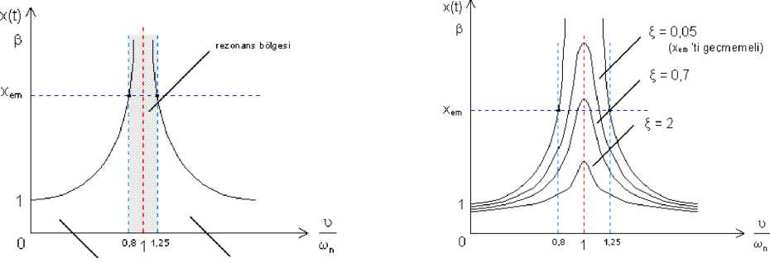

Figure 2 Resonance area

Fatique and fracture can be occured in the system, even if not resonance in the course of time.

Machines expose to mechanic deformation under vibration effect. At the systems take place energy lose from inner fractions. Hence energy lose due to vibrations and fractions are decreased via vibration isolation.

Mechanical vibrations must have been eleminated or restricted for human healthy. Therefore vibrations have been standardised in terms of human healty.

Table 1: Vibration standarts

|  |  |  |  |  |
| --- | --- | --- | --- | --- |
| 300 (5 Hz) | 600 (10 Hz) | 1200 (20 Hz) | 3000 (50 Hz) |  |
| **amplitudes x [mm]** | | | | **Effect** |
| 0,02 | 0,01 | 0,005 | 0,002 | unperceivable |
| 0,02 - 0,056 | 0,01 - 0,03 | 0,005 - 0,015 | 0,002 - 0,005 | understandable |
| 0,056 - 0,16 | 0,03 - 0,08 | 0,015 - 0,04 | 0,005 - 0,015 | perceivable |
| 0,16 - 0,8 | 0,08 - 0,25 | 0,04 - 0,09 | 0,015 - 0,025 | uncomfortable |
| 0,8 - 2,2 | 0,25 - 0,66 | 0,09 - 0,16 | 0,025 - 0,03 | very uncomfortable |
| >2,2 | >0,66 | >0,16 | >0,03 | extremely uncomfortable |

Table 2: Standards in terms of machine healty (L bearing distance)

|  |  |
| --- | --- |
| Lineer | Angular |
| xmax. ≤ xsafe. | θmax. ≤ θsafe. |
| xem. = 10-4. [mm] | θem. = 5.10-6. [mm] |

**Generalized coordinates and primal coordinates:**

Set of coordinates used to describe the motion of a dynamic system. Equation of motion of 2 degree of freedom (DOF) system consist of interconnected two equations. But this two equations can be done independently from another. If coordinates make freedom from another then coordinates are called primal coordinates.

**Equation of Motion of 2 Degree of Freedom (2DOF) System**

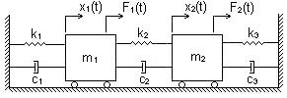

Figure 3. 2 DOF Mechanical system

2 DOF systems have two differential equations and two critical frequency. Equation of motion of 2 DOF system can be obtained as following;

***Using free body diagram;***

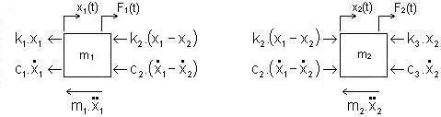

Figure 4. Free body diagram of masses



(1)

(2)

(3)

(4)

(5)

(6)



Can be obtained matrix form as following;



[m], [c] and [k] matrixes are 2x2 and symmetric.

[m]T=[m] [c]T=[c] [k]T=[k]

If in the system c2=0 and k2=0 then this two equations are freedom from another. This mean, two masses are not connected each other. If so [m], [c] and [k] matrixes are diagonal matrix.

(7)



If ***F1=0, c1, c2=0*** and ***k3=0;***



(8)



Can be written as



(9)



(10)



(11)



(12)



**Dynamic absorber (DVA) design**

If a resonance condition occurs in the field, one effective and low cost method to alleviate it is to install a dynamic vibration absorber. The DVA (Dynamic Vibration Absorber) has certain advantages over other methods of vibration suppression. It is external to the machine structure, so no re-installation of equipment is necessary. Unlike with structural modifications, when the final effect is unknown until mass-elastic properties of the machine components have been modified, a DVA can be designed and tested before installation.

At the dynamic absorber approach, Auxiliary mass is added via a spring at the vibrating system. The purpose here is vibrated of the dynamic absorber instead of the system. Vibration of main system is obviated thanks to dynamic absorber design via appropriate mass and spring selection. Dynamic vibration absorbers are designed as damped or. Undamped DVA design can be seen in Figure 5. Here; mass of dynamic absorber, is spring coefficient of the dynamic absorber spring.

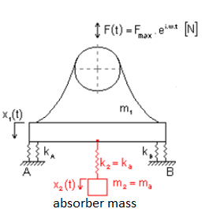

Figure 5. Dynamic absorber application except damper

Here;

 (13)

 : Natural frequency of the system except DVA

 [N] 

  (14)

 and  are critical frequency of the system.

 (15)  (16)

 is main system displacement, and  is displacement of mass of DVA.

If the aim here is  then =0 (17)

   (18)

    : critical frequency of the DVA (19)

 and  (20)

   ,  (21)

In this place mass of DVA must be 0.1-0.3 times more smaller than mass of the main system.

Thus



(22)



In the form of dynamic damper equation can be designed according to the theory, x1 motion is equal to zero when excited main system in the own natural frequency. Accordingly can be seen only x2 motion. DVA is effective at control of one degree of freedom system. But the system have second natural frequency. Thus this is not appropriate variable speed system. Consequently this feature of the DVA system must be take into account while designing.