Yildiz Technical University Department of Mechanical Engineering
Machine Theory, System Dynamics and Control Department of Special Laboratory Course
Dynamic Absorber Design Experiment Report

Laboratory Date: Number:
Name and surname:
Laboratory Director: Group / Subgroup: ... .. / ....

Laboratory Location: A block, between 3. floor and 4. Floor. Machine Theory System Dynamics and Control Laboratory
Laboratory Name: Machine Theory - 2
Subject: Dynamic Absorber Experiment Report

Hardware Devices and Materials Used:
- Student Vibration Mechanism
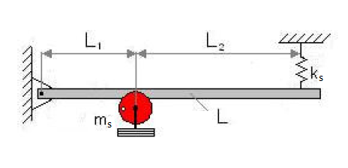
Figure 1. Vibration Experimental Setup

— Computer-MATLAB-SIMULINK
Requirements:
- The students obtain to differential equation of dynamic dump the experimental setup and write the equation in the form of a matrix.
- The students establish a MATLAB-Simulink model for the system and create the .m file to run this program.
- The students determine the natural frequencies and mode shapes of the system.
- The students observe of vibration characteristics of vibration mechanism changing the mass damper.
- The students determine what will be the ideal dynamic damper mass.

Text Template:
Introduction:
The students describe in their words of equation extraction method. Equations will be numbered. Numbers to be in the right.
Method:
The students explain the steps of the establishing the MATLAB-Simulink model in detail.
Experımental Results:
The students show each step of the experimental setup, it will be indicated by the individual figures. Necessary steps will be described.
Results and Comments
The students have results examined in detail , The use of the parameters will be compared with theory and it will be discussed with their own words
Sources
Used sources are written in the format. Format Type:
[1] Metin M. Guclu R., 2010. “Active vibration control with comparative algorithms of half rail vehicle model under various track irregularities”, Journal of Vibration and Control, 17: 1525-1539
Experimental Procedure:
- After the application of resonance vibration sets, results are written in Table 1
Table 1. Measurement Results
Frequency Converter (wd) | Motor Frequency f=(wd*100/2,5)/3,6 | MotorFrequency (rad/s) w=2*π∗f | Measurement values (mm)
2,5 | 1,67 | 10,47
5 | 3,33 | 20,94
5,5 | 3,67 | 23,04
6 | 4,00 | 25,13
6,5 | 4,33 | 27,23
7 | 4,67 | 29,32
7,5 | 5,00 | 31,42
8 | 5,33 | 33,51
8,5 | 5,67 | 35,60
9 | 6,00 | 37,70
9,5 | 6,33 | 39,79
10 | 6,67 | 41,89
12,5 | 8,33 | 52,36

- Natural frequency is determined by the measurement results.
- The spring coefficient of the system is calculated.
a) The distance between the links is measured while spring is in the free form. (δ_{a})
b) After a particular weight connected to spring formed displacement, The distance between the links is measured.(δ_{b})
c) δ_{st} determines.
δ_{st}= δ_{b-} δ_{a}
(1)
d) Applied force to spring is determined.
(2)
F=mg
e) Spring constant of the system obtain with Hooke Law.
(3)
$$k_{s}=F/{δ_{st}}$$
Table 2. Amount of added mass and deflection
Mass (kg) | Free Spring lenght (mm) (δ_{a}) | Mass added spring Length (mm) (δ_{b}) | Deflection (δ_{st})  (m) | k_{s} (N/m)

- Mass of the system is derived from the natural frequency response..

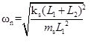
(4)
L₁=0,21 m and L₂=0,43 m .
- Dynamic damper (absorber) spring is connected to the system. Connect the spring coefficient (kd) is obtained according to Hooke's law. Experimental setup is shown in Figure 2.
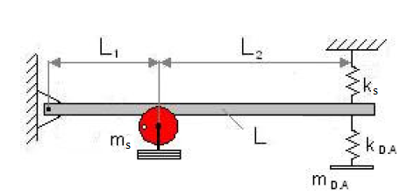
Figure 2. Dynamic absorber experimental setup

- All parameters of the experiment is noted.
- Differential equations of experiment system is obtained. and written in matrix format.
- After equations writing in a matrix form, stiffness and mass matrix is written in MATLAB.
- The natural frequencies and mode shape analysis is performed using the MATLAB command. For this

[V D]=eig(K,M)

MATLAB command used. In this command, There are square of the natural frequency in D matrix. In the V matrix, modal shape of the system is written.
- The program is written and mode shapes values reading, which the experimental results value obtained.The experimental setup with changes in the Dynamics of movement damper unit observed. This reading is repeated for each frequency.
- md= (0.2÷2)md, Md to be replaced. Dynamic absorber mass change with the form of the movement changes of the experimental setup is observed. Observation results are shown changes in the movement patterns in both frequencies.

