YTÜ Mechanical Engineering Department
Machine Theory, System Dynamics and Control Division - MAK 4981 LABORATORY
Dynamics of Machinery – Lab Report

Lab. Date: Number:
Name & Surname:
Lab. Instructor: Group/Sub‐group: ….. / ….

Location: A Blok – Machine Theory Laboratory
Name: Dynamics of Machinery
Subject: Resonance Analysis

Device and Material:
- Vibration Test Beam Setup
- Ruler
- Sample mass

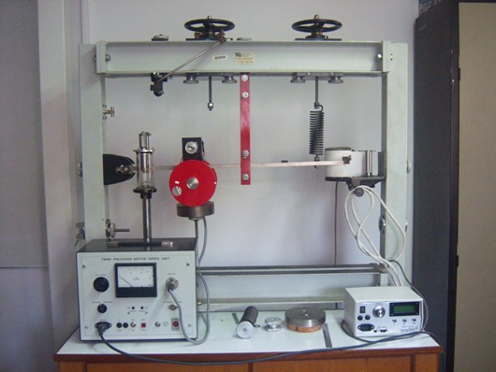
Figure 1 Experimental Test Setup
Required
For given Experimental Test Setup;
- Determine the natural frequency of the system experimental method.
- Determine the parameters of the system with experiment.

Experimental Study:
To begin with,
- Measure the distance between the referance point of the ruler and the beam ……. (m).
- Fill the table given below with respect to the dispacements of the beam.

System Frequency | Frequency:  f (x100/2,5) (Hz) | Frequency  $$ω=2πf$$ | Displacement  (m)
2,5 | 100 | 10,47
5 | 200 | 20,93
5,5 | 220 | 23,03
6 | 240 | 25,12
6,5 | 260 | 27,21
7 | 280 | 29,31
7,5 | 300 | 31,40
8 | 320 | 33,49
8,5 | 340 | 35,59
9 | 360 | 37,68
9,5 | 380 | 39,77
10 | 400 | 41,87
12,5 | 500 | 52,33

- Plot amplitude versus frequency with respect to your displacement measurements.
- Find the natural frequency of the system. (Recall: the peak point of the graph shows the natural frequency of the system.)
Amplitude (mm)
Actuator Frequency (rad/sec)

Analytical Study
- Step: Calculation of the stiffness constant
  - Measure the distance between two end points of the spring in steady state condition: ….(m)
  - Disassemble the spring. Measure the distance between two end points of the spring: ….(m)
  - Attached some weight to the spring. Measure the distance between two end points of the spring: ….(m)
Added Mass (kg) | $δ_{(c-b)}$ (mm) (c-b) | $δ_{(a-b)}$ (mm) (a-b)

  - Calculate the stiffness of the spring (K)
Hint: $F=kδ_{3-2}$;
Where, g=9.81 and F is the applied force on the spring

- Step: Calculation of the natural frequency
  - Calculate the mass of the system
Hint: Take the moment of the system with respect to the fixed point of the beam (O)
$F_{Spring=}\frac{M_{system}δ_{(a-b)}}{δ_{(c-b)}}$ 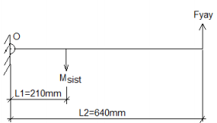

  - The differential equation is as follows;
$$J\ddot{ϑ+k{L_{2}}^{2}θ=F\left(t\right)L_{1}}$$
Where, $J=M_{system}{L_{1}}^{2}$=………(kg.m²)

Finally, the natural frequency of the system;
$$ω_{n}=\sqrt{\frac{k{L_{2}}^{2}}{J}}$$
Results
$ω_{n}$ obtained from the experimental test | K(N/m) | J(kg.m²⁾ | $ω_{n}$ obtained from the experimental test

Discussion
…………………………………………………………………………………………………………………………………………………………………………………………………………………………………………………………………………………………………………………………………………………………………………………………………………………………………………………………………………………………………….

